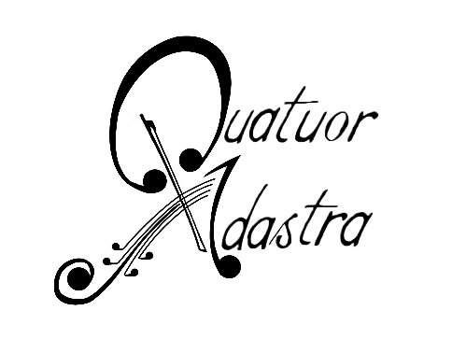
Adastra Quartet Biography

« Ad Astra Per Aspera »

To the star, through difficulties... Is there a better way to describe the demanding practice of string quartet, leading a musician's extreme fullfilment while always aiming to the impossible ?

Formed in 2013 in the Academie Supérieure de Musique of Strasbourg, its members share their enriching and intimate approach of chamber music. They find their first support in the members of Parisii string Quartet, encouraging them to perservere in their endeavours.

In 2015, the Adastra Quartet enters the specialised course of the Debussy Quartet in Lyon and is awarded the scholarship of the Music Academy of Flaine for three years in a row, where it receives guidance from Yovan Markovitch and Luc-Marie Aguera (Ysaye Quartet).

The following year, the Quartet is selected for the musical springboard for Young Quartets at the Philarmonie in Paris. They are also part of the Proquartet institution allowing them to take parts in masterclasses with Irvine Arditti and Phillippe Manoury. They also receive advices of great Masters such as Berg, Danel, Manfred and Ludwig Quartets.

Defending a very open approach of music, the Adastra Quartet does not hesitate to get involved in projects inside and outside the world of classical music, taking part in Jazz, Theatre and Contempory productions. The repertory of the quartet beeing is just as diversified as its various projects, including Haydn, Schubert and Shotakovitch but also Piazzola and Colt silvers.

The Quartet is invited to severals chamber music festivals in France and played in prestigeous venues such as Fontainebleau Castle, the Museum of Arts in Lyon, Théâtre Européen du Maillon in Strasbourg... They are also invited by the European Parliament to cover official ceremonies and events with a live streaming on various european medias.

Encounters with talented artists inclunding the composer Phillipe Manoury or the very famous Arditti Quartet bring the young musicians to express a great interest for contemporary music, leading them to an appearance in the well know « Festival Musica » in Strasbourg and work with solists from the « Ensemble Modern » as well as the composer Pascal Dusapin.

From classical to contemporary music, from Theatre to Opera, the quartet does not leave out any artistic field. They collabored many time as a leading quartet in Opera productions in prestigeous institutions such as Opera National du Rhin.

The members of the Adastra Quartet are also very aware of the power of music on strenghtening social ties, and they agree to take part in cultural events supporting great causes such as Disease Control.

